Strategic Planning Information Request

l = Currently Exists m= Need to Develop
Item | Ref |  | Description/Comments | Business Unit |  |  | Responsibility
Item |  |  | Description/Comments | BU-1 | BU-2 | BU-3 | BU-1 | BU-2 | BU-3
Mission Statement | (a) | Current State: What do we do? Our purpose for being?
Vision Statement | (b) | Future State: Where are we going?
Major Changes from Last Year | (c) | Provide significant differences in business conditions, competition, technology, markets, etc.
3-Year Historical Sales & Profitability | (d) | Total, By Product Category, Channel, Country (if applicable)
Operations & Supply Chain Analysis | (e) | Provide key operational and supply chain data per template (e)
SKU Analysis | (f) | Provide the # of active SKUs by product line as well as the # of SKUs that make up 80% of your total revenue for that category
Technology Trends | (g) | Tech Trends that might impact the future of the business
Market Size, Market Share & Market Growth | (h) | By Product, By Geography - Include Competitor Data if possible
Customer Segmentation | (h) | By Product & Geography
Key Competitors and Market Share | (h) | May need to segment by product and/or geography
Competitor Analysis | (i) | How does NHB compare to competition across product segments?
SWOT - STRENGTHS | (j) | List STRENGTHS that are INTERNAL to your business
SWOT - WEAKNESSES | (k) | List WEAKNESSES that are INTERNAL to your business
SWOT - OPPORTUNITIES | (l) | List OPPORTUNITIES that are EXTERNAL to your business
SWOT - THREATS | (m) | List THREATS that are EXTERNAL to your business
Human Capital | (n) | Analysis of your human capital talent - Gaps to support your plan.
Reference Notes appear on the following pages…

Reference Notes:

- Mission Statement Examples:

Defined: Current State: What do we do? Our purpose for being?

Coca-Cola: “To craft the brands and choice of drinks that people love, to refresh them in body & spirit.”

Starbucks: “To inspire and nurture the human spirit – one person, one cup, and one neighborhood at a time.”

- Vision Statement Examples:

Defined: Future State: Where are we going?

Amazon: “Our vision is to be earth's most customer-centric company; to build a place where people can come to find and discover anything they might want to buy online.”

Tesla: “To create the most compelling car company of the 21st century by driving the world’s transition to electric vehicles.”

- Major Changes from Last Year Example:

Defined: Provide significant differences in business conditions, competition, technology, markets, etc.

- Kaizen improvements in our New Product Development process (time to market from 48 months to 12 months) will provide a significant competitive advantage with new product entries
- New European environmental regulations will require that we redesign our packaging to be eco-friendly, consistent with the new regulations
- Labor market has become extremely competitive and high employee turnover has major implications to meeting ever-increasing customer demands
- Include leading indicators that are relevant to your business. For example:
  - Housing starts
  - Inflation projections
  - Consumer confidence
  - etc…

- 3-Year Historical Sales & Profitability:

It is useful to segment revenue into the following categories:
- Strategic
- Opportunistic
- Sustain

The following template might be useful in aggregating this data:

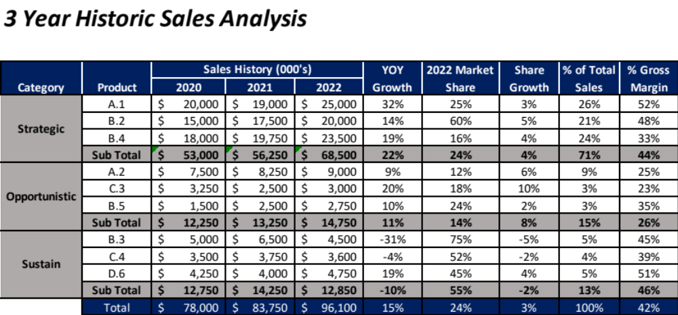

- Operations and Supply Chain Analysis:

Item | Business Unit
Item | KASA Corp | NA USA | NA Canada | EMEA | LaMEX | APAC |  | Comments
Product Quality - Internal | l | l | l | l | l | l
Product Quality - Warranty | l | l | l | l | l | l
Delivery Performance | l | l | l | l | l | l
Lead Time vs. Competition | l | l | l | l | l | l
Product Cost | l | l | l | l | l | l
Supplier Reliability | l | l | l | l | l | l
Operational Capacity | l | l | l | l | l | l
Lean Capability | l | l | l | l | l | l
Labor Market | l | l | l | l | l | l
Innovation Strength | l | l | l | l | l | l
Product Management Capability | l | l | l | l | l | l
Key - Rating: l = Strong, l = Neutral, l = Weak

- SKU Analysis
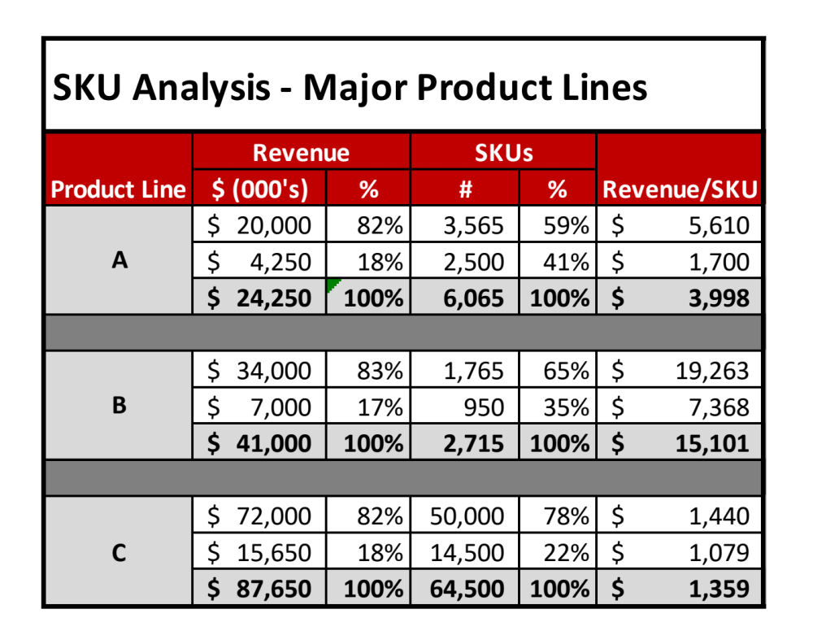
- Technology Trends - Examples:

Defined: Tech Trends that might impact the future of the business

- Competition has developed a lithium battery WIDGIT that has wide market appeal. This will require a transition to convert our product line from AC power to a battery-operated platform
- Driver navigation capabilities are being developed in smartphones which will make our stand-alone navigation equipment obsolete
- Cordless table-top appliances are replacing traditional AC-powered products

- Market Analysis & Customer Segmentation

The following template might be useful in aggregating this data:

Region/Geography: United Kingdom
Market: | Mixers | Large Kitchen | Food Processing
Market Size: | $125 million | $400 million | $50 million
Brand Sales/Share: | $75 million/60% | $100 million/25% | $10 million/20%
Brand Growth Rate: | 5% | 7% | 12%
Key Customers: | Big Box | Home Improvement | Big Box
Key Success Factors: | Price, Ease of Use, Portability | Warranty, Quality Reputation, Energy Efficiency | Price, Ease of use
Key Products: | Stand Mixer | Dishwashers (growth opportunity) | Slow-cooker
Trends: | Innovative Accessories | Energy Efficiency, Noise Reduction | Multi-tasking capabilities
Brand Strengths: | Legacy name recognition | Legacy name recognition | None
Brand Weakness: | Innovative accessories | Price from Asian competitors | No brand identity
Key Competitors: | Asian copycats | LSG, GE | Ninja
Winning Strategies: | Develop innovative accessories, Value Analysis to reduce product cost | Innovative advertising, Value Analysis to reduce cost | Develop VOC to ID competitive weaknesses, develop & market new capabilities

- Competitor Analysis:

The following template might be useful in aggregating this data:
Item | KASA | Competitor |  |  | Comments
Item | KASA | A | B | C | Comments
Channel Strength | l | l | l | l | Channel the major strategic issue
Product Quality | l | l | l | l | Quality not a major factor with top competitors
Price Comparison | l | l | l | l | China government subsidizing competition a major concern
Customer Service & Support | l | l | l | l | Need to reengineer customer service and technical support
Brand Awareness | l | l | l | l | Drive “Made in America” brand
Delivery Performance | l | l | l | l | Work with Supply Chain to improve
Product Breadth | l | l | l | l | No major difference with competition - need a breakthrough
Technological Strength | l | l | l | l | Our products lag competitor IOT capabilities
Key - Comparative Ranking: l = Strong, l = Neutral, l = Weak

- SWOT - Example of STRENGTHS (Internal to the Business):
Our salesforce is highly experienced and have ensconced customer relationships

- SWOT - Example of WEAKNESSES (Internal to the Business):
Our New Product Development “time to market” lags competition by 75%

- SWOT - Example of OPPORTUNITIES (External to the Business):
Espresso making is intimidating for the home user, and simple, innovative, proprietary in-home espresso products could revolutionize the espresso market

- SWOT - Example of THREATS (External to the Business):
The conversion from fossil fueled vehicles to electric automobiles will challenge our traditional gas-powered vehicle product platform

- Human Capital Gaps to Support your Strategy:
What technical, management, and leadership talent is required to support your strategy?

